|  |  |  |  |  |  |
| --- | --- | --- | --- | --- | --- |
| **Key Vocabulary** | | | | | |
| **Vertical (jump)** - A vertical jump is a movement that is used in a number of sports. The primary goal of a vertical jump is normally to reach the greatest possible height. | **Measuring** - take an exact quantity of something. How high did you jump? | | **Obstacles** - something that blocks you so that movement, going forward, is more difficult. | | **Lead (leg)** - The lead leg is the first leg to clear the hurdle.  **Trail (leg)** - The trail leg is the second leg to clear the hurdles. |
| **What you need to be successful?** | | | | | |
| **How to Jump for height.** | | **How to jump over a hurdle successfully.** | | **How to run for speed successfully.** | |
| * Bend your knees upon taking off to begin a jump and bend your knees upon landing to soften the impact. * Use your arms to gain momentum and balance. | | * The lead leg is the leg which clears the hurdle first. * Once clear of the obstacle the lead leg should be pulled down quickly to push away from the ground into the next running stride. * The trail leg is the following leg, and the knee should be picked up parallel to the obstacle with the ankle tucked in and the foot turned outwards. | | * Think about the quality of your movements, move with controlled speed. * Remain completely still in the starting position, listen carefully for the "G" of "Go" and not to guess, keep low and drive the arms as you come up out of the starting position. | |
| **Building Blocks to Success** | | | | | |

**Pictures of Skills**

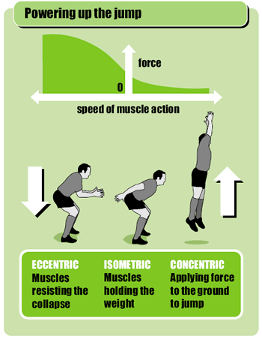

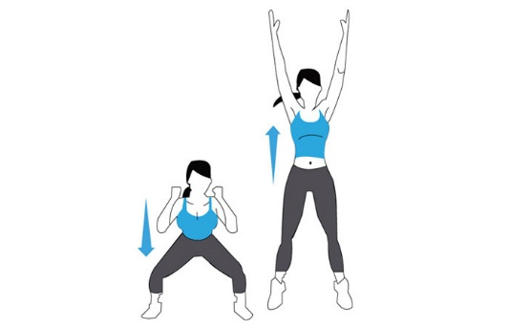

**Jumping (Height)**

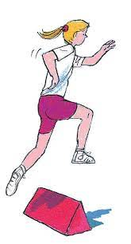

**Hurdling Technique**

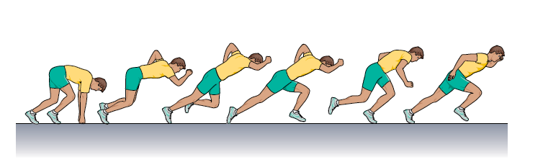

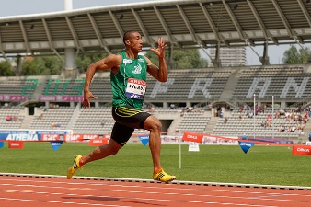

**Sprinting**